Ex.no:5b | DATA VISUALIZATION USING MATPLOTLIB –  SALES DATA

AIM

To visualize and analyze the California Housing Dataset using Line Chart, Bar Chart, and Pie Chart with Matplotlib to understand housing value trends, ocean-proximity-wise comparisons, and housing distribution across different locations.

ALGORITHM

Step 1: Import Pandas and Matplotlib libraries.

Step 2: Load the California Housing Dataset into a DataFrame.

Step 3: Group the housing data according to ocean proximity and calculate the average median house value for each category.

Step 4: Plot the ocean-proximity-wise house values using a Line Chart to observe variations in house values across different locations.

Step 5: Group the dataset according to ocean proximity and calculate the total number of housing records for each category.

Step 6: Plot the housing records using a Bar Chart to compare the number of houses across different ocean proximity categories.

Step 7: Select the major ocean proximity categories and calculate their proportions in the dataset.

Step 8: Plot the housing distribution using a Pie Chart.

Step 9: Add suitable titles, axis labels, legends, and display the visualizations.

CODE
import pandas as pd
import matplotlib.pyplot as plt

# Load California Housing Dataset
df = pd.read_csv(
"housing prices.csv",
low_memory=False
)

# --------------------------------
# 1. Line Chart – House Value by Ocean Proximity
# --------------------------------

house_value = (
df.groupby("ocean_proximity")["median_house_value"]
.mean()
.sort_values(ascending=False)
)

plt.figure(figsize=(10, 5))

plt.plot(
house_value.index,
house_value.values,
marker="o"
)

plt.title("Average House Value by Ocean Proximity")
plt.xlabel("Ocean Proximity")
plt.ylabel("Average Median House Value")
plt.xticks(rotation=45)
plt.grid(True)
plt.tight_layout()

plt.show()

# --------------------------------
# 2. Bar Chart – Houses by Ocean Proximity
# --------------------------------

house_count = (
df["ocean_proximity"]
.value_counts()
.sort_values(ascending=False)
)

plt.figure(figsize=(12, 6))

plt.bar(
house_count.index,
house_count.values
)

plt.title("Number of Houses by Ocean Proximity")
plt.xlabel("Ocean Proximity")
plt.ylabel("Number of Houses")
plt.xticks(rotation=45, ha="right")
plt.tight_layout()

plt.show()

# --------------------------------
# 3. Pie Chart – Housing Distribution
# --------------------------------

housing_distribution = (
df["ocean_proximity"]
.value_counts()
.sort_values(ascending=False)
)

plt.figure(figsize=(8, 8))

plt.pie(
housing_distribution.values,
labels=housing_distribution.index,
autopct="%1.1f%%"
)

plt.title("Housing Distribution by Ocean Proximity")

plt.show()

OUTPUT
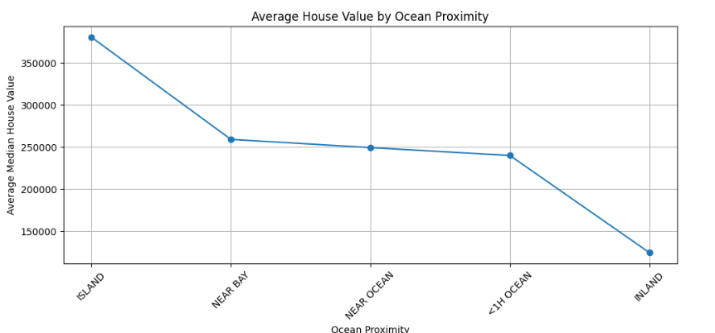
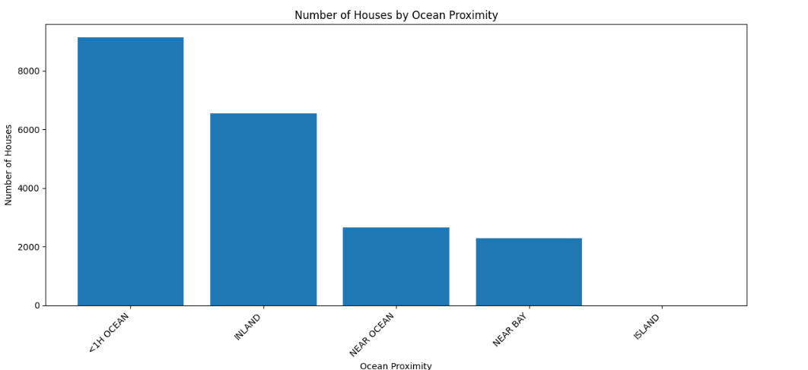
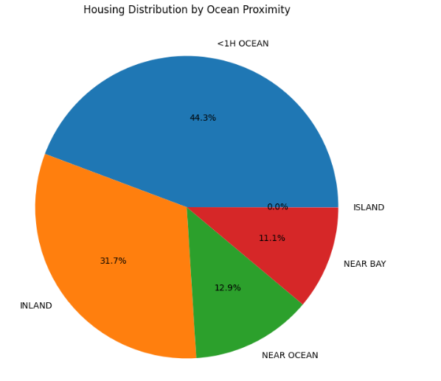

RESULT

